Installing Atom Code Runner

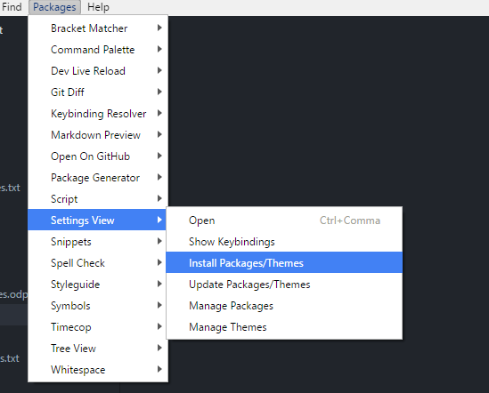

Inside Atom click the above: Packages->Settings View->Install Packages/Themes

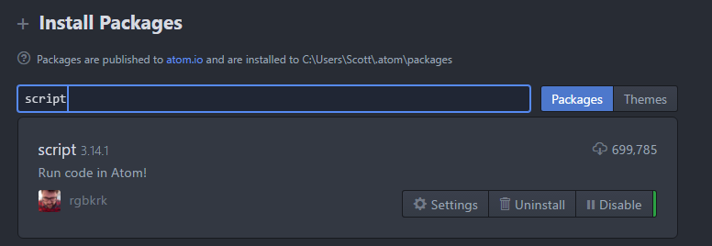

Search for “script” under Packages and click “Install” on this package, once complete restart Atom.

Now open some Python code, for example helloworld.py

Click inside your code so you get the flashing text cursor, the hit Ctrl + Shift + B

Which will run your code and display the results below:

